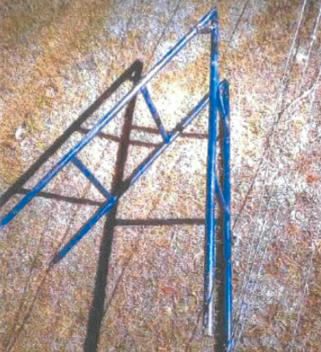
The fence ladder used by hunters in the corner-crossing case. (Wyoming Game and Fish)

